Saint Piran

Present on behalf of the RNRMCA

The Interservices
10 & 25 Championships 2024

Event Sponsored by:



BIKE CHAIN RICCI

Saturday 18th May 2024 - 10 Mile Time Trial - Course U30/10 @ 1800

Sunday 19th May 2024 - 25 Mile Time Trial - Course U30/25r @ 0800

Event HQ
Nuffield Sports Pavilion
RNAS Yeovilton
(Opposite Museum Entrance)
Follow signs for Fleet Air Arm Museum. Allow 10 mins to ride to start.

(Promoted for and on behalf of Cycling Time Trials under
their rules and Regulations)
Event Secretary

Tom Cox
4 Hine Road
Taunton
Somerset
TA1 4NE

Telephone 07717 941632

IN THE INTEREST OF YOUR OWN SAFETY, Cycling Time Trials and the event Promoters insist on both HARD SHELL HELMET that meets an internationally accepted safety standard and working front and rear lights in line with current CTT Regs.
Important Notes:-
- Numbers will be at the start and can be exchanged for a drink at the end
- Numbers MUST be signed back in to the HQ after the event or riders will be disqualified.
- Riders are to ensure that they read the course risk assessment (which will be next to the numbers at the HQ) prior to starting the event
- No U-Turns within sight of the Start and Finish Timekeepers
- One Rider - One prize
- NUMBERS, REFRESHMENTS, CHANGING ROOMS, SHOWERS and TOILETS are at the HQ. Numbers will be available at the HQ and must be returned there for a free drink.
- Riders to have working front and rear lights no lights means no ride as per CTT Regulations
- Riders are to have helmets to ride in this event as per CTT Regulations
- Please Note - although entries were separate for men and women, for ease of sorting out the events the ladies are all grouped together.
- Two ladies (Tina Hartnell and Gemma Simister) entered the men’s event in error online and the dreaded computer wont let me move you. I have placed you within the ladies grouping but you will find your start times within the men’s field listing at numbers 117 and 18. Apologies for that.

Course Details: Saturday 18th May - 10 Mile Time Trial U30 /10

COURSE: Start at the 2nd drain cover west of the 30mph sign on the western side of Podimore village.
Proceed to Podimore roundabout and take first exit (A303 westwards),
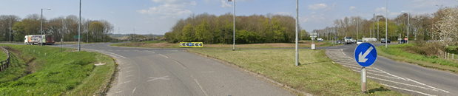 continue straight along the A303 to the Tintinhull/Ash flyover, immediately after passing under the flyover turn left (signpost Tintinhull).

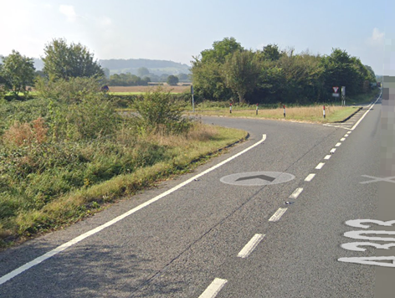

At the T-junction turn left over the bridge left again (adverse camber signpost London),

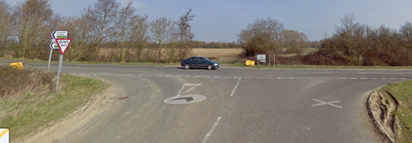
and then then left to rejoin the A303 eastwards.
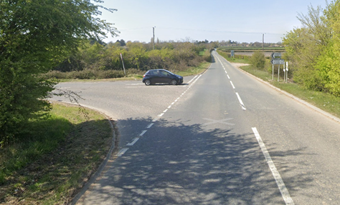
Take care when rejoining the A303 at the turn there is no slip road; keep in close to the kerb.
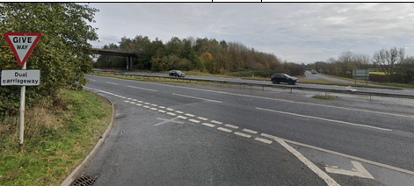
Retrace to finish approx 400 metres before Podimore roundabout.

On completion of the course do not suddenly slow or vary your line, remain on the inside lane and obey the traffic lights. If it is safe to do so cross to the outside lane on the roundabout otherwise take the first exit (Langport) and continue on to the Lytes Cary junction, where you may turn in safety. Take care when crossing the Podimore roundabout returning to the finish.

Course Details: Sunday 21st May - 25 Mile Time Trial U30 /25r

COURSE Start at the 2nd drain cover west of the 30mph sign on the western side of Podimore village.

Proceed to Podimore roundabout and take first exit (A303 westwards), continue straight along the A303 to the Cartgate Roundabout.

Circle Cartgate Roundabout and take the last exit to re-join the A303 going eastbound to A37 slip with A303.
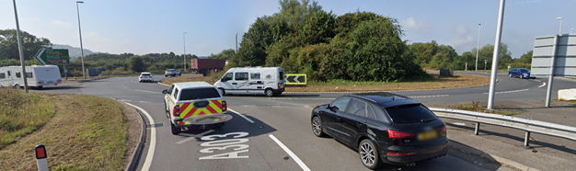

At A303/A37 Slip,
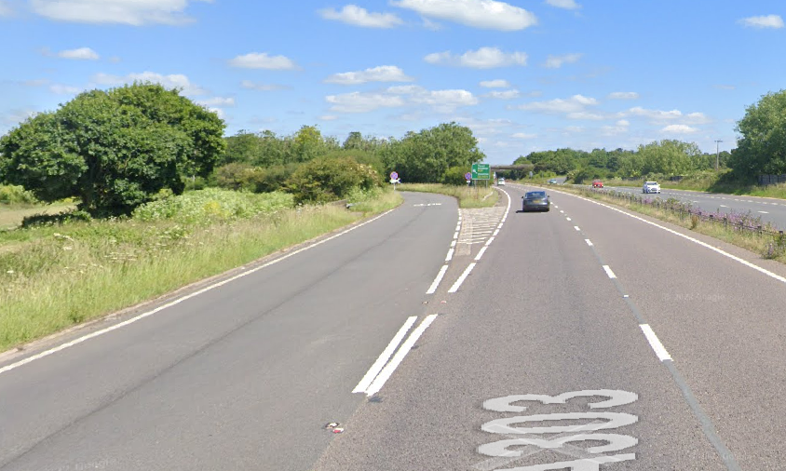
Turn left proceed over the bridge to roundabout at Ilchester

Where circle and take the last exit to retrace route on A37 slip road to re-join A303 going west bound.
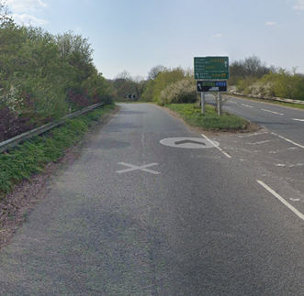

Continue on A303 to Cartgate Roundabout
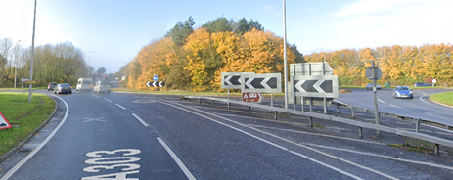

Continue straight across on A303 to South Petherton Roundabout

Where circle and retrace eastwards on A303 to Cartgate Roundabout
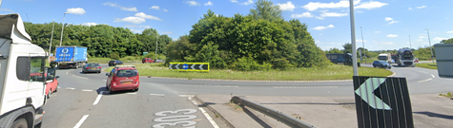

Straight over and continue on A303 to finish approx 200yds short of the Podimore Roundabout.

On completion of the course do not suddenly slow or vary your line, remain on the inside lane and obey the traffic lights. If it is safe to do so cross to the outside lane on the roundabout otherwise take the first exit (Langport) and continue on to the Lytes Cary junction, where you may turn in safety. Take care when crossing the Podimore roundabout returning to the finish.. Take care when crossing the Podimore roundabout returning to the finish.

Please note this is a revised course and riders must ensure that they are fully aware of the route prior to starting!

Timekeepers: - Mr Andy Greatwood, Mr Dennis Davies, Mrs Sally Hutter – 18th May
Mr Andy Greatwood, Mr Dennis Davies, Mrs Sally Hutter –19th May

Prize List for each championship event
1st Man - £30
2nd Man - £20
3rd Man - £10

1st Man Road Bike - £20

1st Lady - £30
2nd Lady - £20
3rd Lady - £10

1st Lady Road Bike - £20

RNRMCA Awards - as per RNRMCA schedule and available only to RNRMCA riders - TBA

